COMP3000HK Computing Project

2025/2026

Project Title
A Machine Learning Approach for Identifying Psychological Triggers in Phishing Emails to Enhance User Awareness.

Links
Source code: https://github.com/hkuspace-pu/project-wongoining.git

Project Vision
This project aims to support general email users by improving their ability to recognise social engineering attempts. IT addresses the problem that current phishing alert systems lack psychological context, which results in low user awareness and increased vulnerability to advanced social engineering attacks. The project proposed a AI-Enhanced Phishing Awareness System in a machine-learning-based detection and explanation framework that analyses the text of emails to identify and highline psychological triggers commonly used by attackers, such as urgency, authority, and scarcity.
By providing clear, contextual feedback, the system aims to improve users’ long-term understanding and resistance to phishing attempts.

Risk Plan
Time:
The project may face time overruns in the technical stages such as model building, data training, or system development. To manage this risk, the project is divided into two phases. If any part exceeds the planned schedule, the scope of the user study will be reduced to ensure that the core implementation can still be completed within the deadline.

Technical:
Data Quality:
The available datasets for phishing detection may not be sufficient or balanced enough for effective model training. To address this, multiple public datasets will be combined to increase data diversity. In addition, a small portion of the data will be manually tagged to improve the accuracy and reliability of the psychological feature labels used for training.

Model Explainability:
Since the project relies on interpretable AI feedback, some complex models may produce unstable or unclear explanation outputs. This could reduce the system’s ability to highlight psychological cues accurately. To mitigate this, simpler and more interpretable models, such as tree-based classifiers, will be prioritised. Feature optimisation will also be applied to improve the stability and clarity of the explainability results.

Proposed Gantt chart
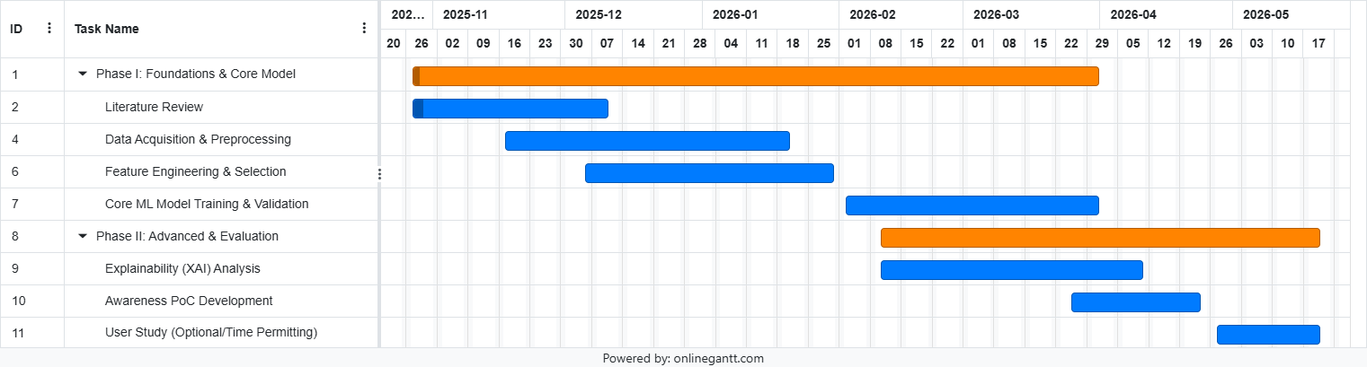

Detail of Time arrangement (the Gantt Chart is also available in GitHub):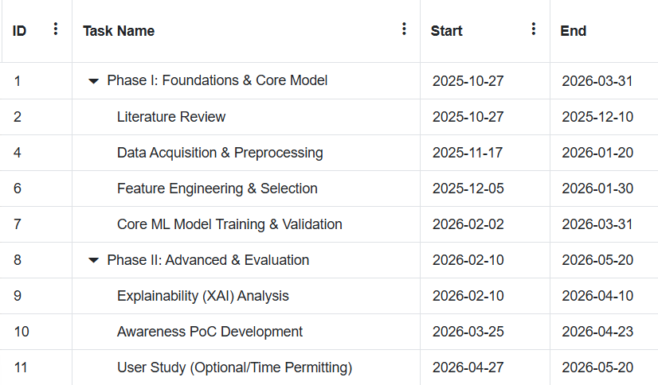

Keywords
Social Engineering, Phishing Detection, Natural Language Processing, Machine Learning

